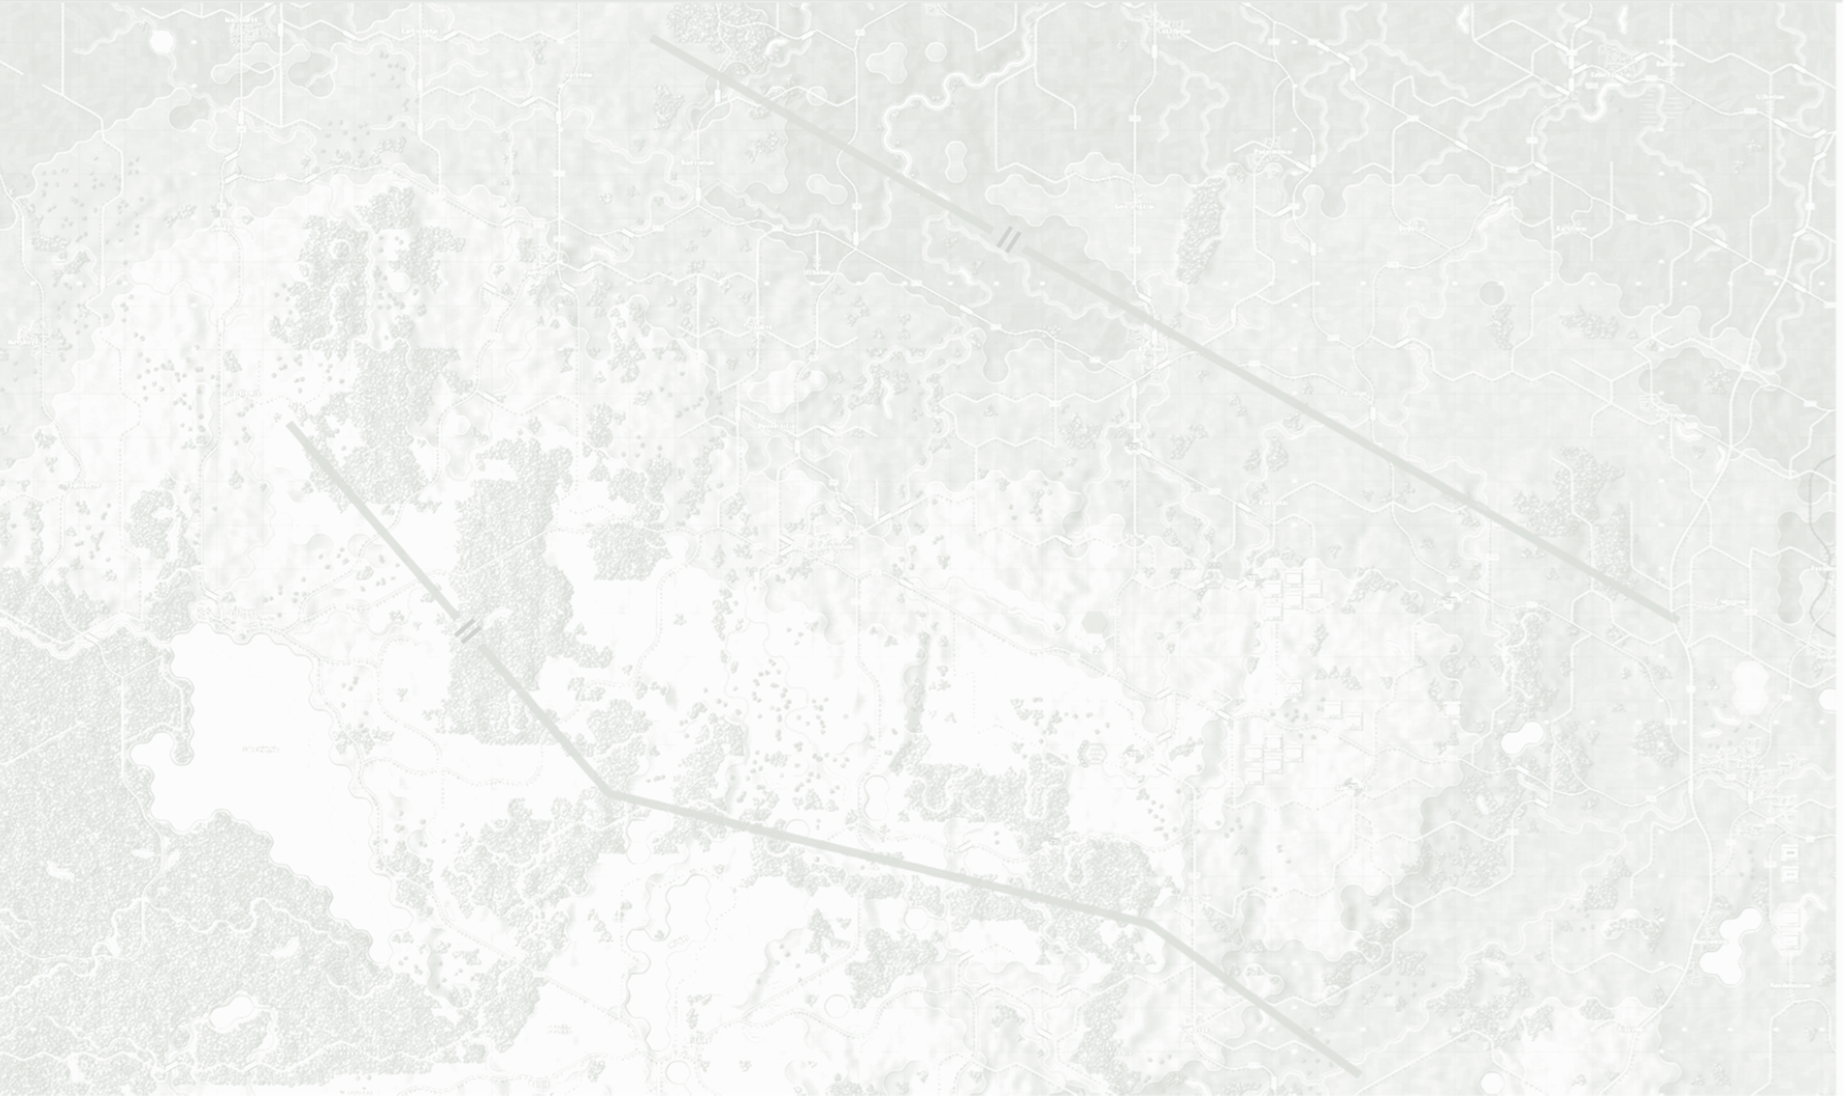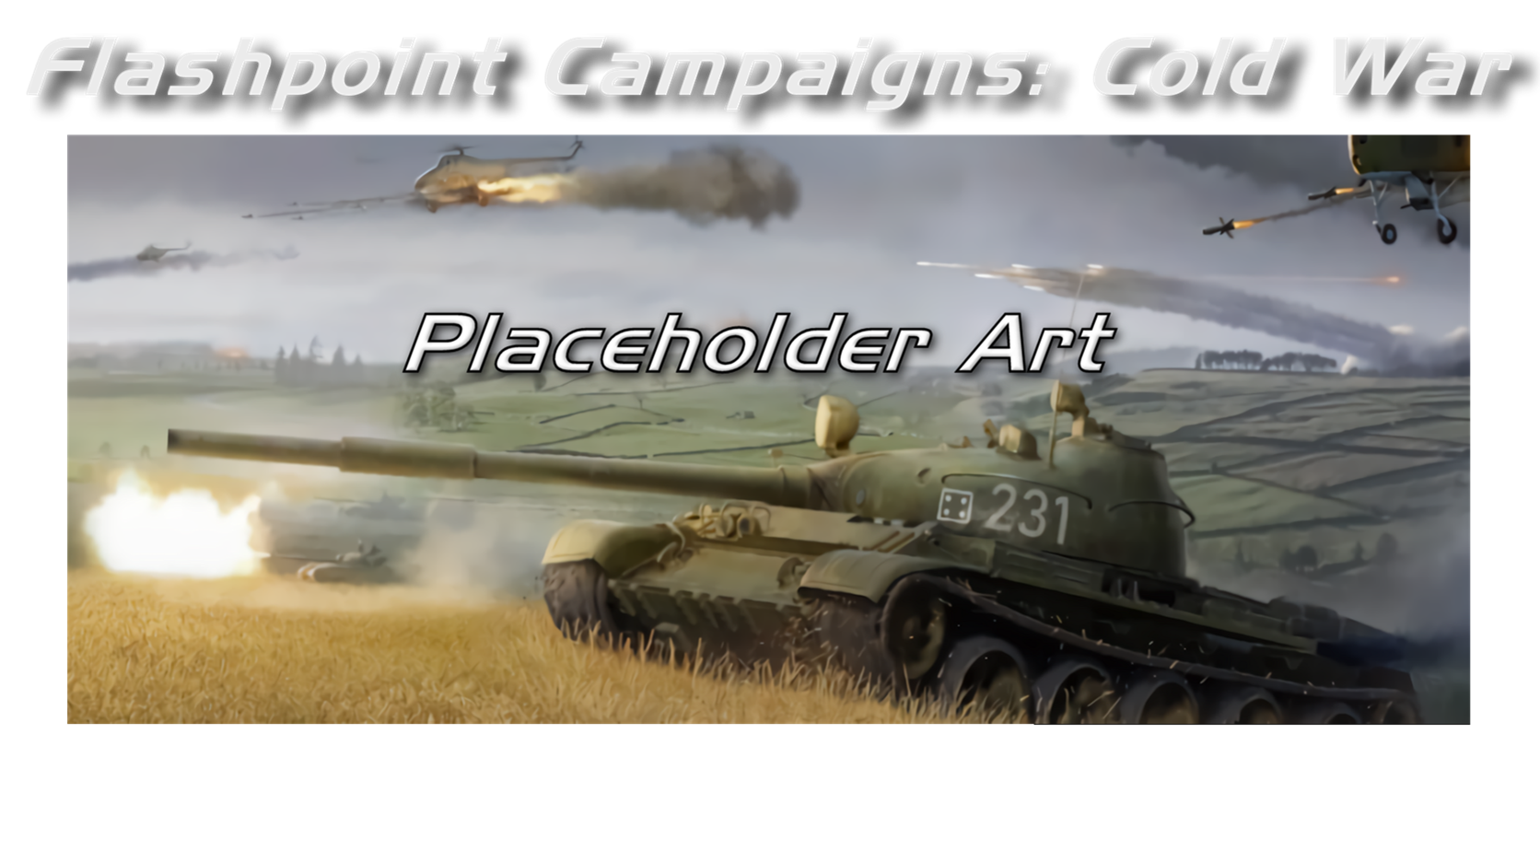

Campaign Design

Field Manual FCCW-06/R0

**© 2025 On Target Simulations, LTD. All Rights Reserved. The images used and OTS Logo are property of On Target Simulations, LTD. All other marks and trademarks are the property of their respective owners.**

Table of Contents

1 Introduction 4

1.1 What's in This Document 4

1.2 Manuals 5

1.2.1 The Field Manuals (FM) 5

1.2.2 What’s New 5

1.2.3 FPC Hotkeys 5

1.2.4 Flashpoint Campaigns: Cold War FAQ 5

1.3 Gender Pronouns and Inclusion 5

2 Creating a Campaign Scenario 6

2.1 Creating a Core Force 6

2.2 Naming of the Campaign Scenario 11

3 Campaign Editor 11

3.1 Create a Campaign 11

3.2 Edit a Campaign 14

4 Tips, Tricks, and Best Practices 16

5 Flashpoint Campaigns Credits 18

5.1 On Target Simulations 18

5.2 On Target Simulations Content Team 18

5.3 Cold War Beta Testers 18

5.4 Matrix Production Support 18

6 OTS on the Web 19

# A military tank in a field AI-generated content may be incorrect.Introduction

Welcome to FLASHPOINT CAMPAIGNS: COLD WAR

This is a grand tactical combat simulation on the Cold War battlefield. As the force Commander, you will plan and then issue orders and Standard Operating Procedures to your battalion, brigade, or regimental forces, shaping the fight by maneuver and your intent. Your forces will engage the enemy on rendered real-world map locations. Each hex is 500m of militarily significant terrain. Each battle can last 4 to 24 hours of in-game time. Your troops will meet their foes any time of day and in any environment.

The game engine is based on asynchronous WEGO turns. This means you will issue orders and then watch a variable amount of time unfold on the battlefield. Then, issue or adjust orders to react to what has happened as you execute your battle plan.

***Flashpoint Campaigns: Cold War*** is a deep simulation of combat operations where your forces are arranged in maneuver units of companies, platoons, and sections of tanks, infantry fighting vehicles, infantry squads and teams, recon forces, engineers, air-defense and anti-tank systems, helicopters and more. As the Commander, you must use available off-map assets like long-range artillery, rockets, or airstrikes.

Your efforts in this complex battlespace will be constantly challenged by modeled features like Electronic Warfare, Air Superiority, Realistic Weather, Line of Sight and Fire, Terrain and Elevation, Smoke and Mines, and Human Factors like training, morale, and readiness. All these elements must be considered if you are to be victorious on the battlefield.

The game is packed with information dialogs, map overlays, and range rings to aid you as Commander, master the situation, and understand your force’s capabilities.

***Flashpoint Campaigns: Cold War*** is a data-rich simulation where each nation has information on National Characteristics, Command Parameters, and Orders of Battle. Data Tables are packed with era-specific equipment and troops. Weapon Systems of the time, such as guns, missiles, precision munitions, small arms, and much more, are comprehensively modeled.

As a toolkit, you can create your own scenarios and campaigns. You can also dive deeper and create or modify game data, artwork, and sound effects as you see fit. All these modding capabilities are supported by detailed documentation.

## What's in This Document

This document provides detailed instructions on playing and creating Campaigns using the Flashpoint Campaigns - Cold War Game engine. Whether you're a beginner venturing into the world of campaign creation or an experienced player seeking to enhance your skills, you'll gain valuable insights into the intricacies of creating campaigns.

**NOTE:** Areas of interest or buttons on form pictures are outlined in red.

**NOTE:** Some images in this manual are from other game versions. While your maps and units may differ, all the information and how it is used and displayed will match the information in this manual.

* 1. Manuals

We have chosen to go with many living manuals to cover game interface/play, learning the game, basic tactics, Content Creation, and Game Modding for the Cold War game engine. We also have guides that cover that area of operations. The affected manuals and guides will be updated as the game is updated, and PDFs of these changes will be included with the new patches.

### The Field Manuals (FM)

These are the core manuals on how to play, create content for, and modify data for the Cold War game engine. Before jumping into Content Creation, we strongly recommend you review the first three manuals, **Game Operations**, **Battlefield Primer**, and **Tutorial Operations,** if you are new to this type of game and warfare. Returning Flashpoint Campaigns players should review **Game Operations** to get details on new features, as there are many.

These documents are found in the Documents\FMs folder.

* FM01: Game Operations – Detailed information on the game, its interface, and how to use it
* FM02: Battlefield Primer – Fighting in the Cold War
* FM03: Tutorial Operations – How to learn and play the game
* FM04: Scenario Design – How to make or edit scenarios
* FM05: Battle Planning – How to create or edit battle plans. Battle Planning is a unique topic of Scenario Design.
* FM06: Campaign Design - ***This Manual*** – How to make or edit campaigns
* FM07: Map Construction – How to make simple maps for the game
* FM08: Game Engine Modifications - How to Mod elements of the game engine
* FM09: Data Structures and Editing – How to edit or build data sets
* FM10: Weather Setup – How to add in weather from other locales

### What’s New

The What’s New PDFs summarize any changes and fixes when updates are released.

These can be found in the Documents\WhatsNew folder.

### FPC Hotkeys

This PDF document lists all the unique game key presses for Function keys and all hotkey definitions. Due to the large number of functions in the game, rebinding is not possible.

This document is in \Documents folder.

### Flashpoint Campaigns: Cold War FAQ

To stave off forum-clogging threads on various topics we either don't control or can't support, we created this FAQ document with the answers to those specific topics.

Please review the FAQ for answers to several game topics related to the game but not on how to play the game.

This document is in the \Documents folder.

* 1. Gender Pronouns and Inclusion

We understand that users of all genders will play our simulation. We try to keep language in the game and manuals gender-neutral, when possible, but sometimes use the pronoun “he” to refer to the user. This is merely to streamline the writing, not to exclude anyone or note a specific gender.

The On Target Simulations team supports the inclusion of all people in the field of wargaming.

# Creating a Campaign Scenario

In this section, we will cover how to create a Core Force and the naming of the Campaign scenarios.

When developing a campaign scenario, you should aim to create a series of two (2) to five (5) scenarios using the **FM04 Scenario Design** guideas your reference for making each scenario**.**

## Creating a Core Force

These are the forces that will be carried forward from scenario to scenario as the campaign progresses. Everything not designated as a core force will be an ‘attachment’ that has a lifespan restricted to one scenario. Typically, the various maneuver forces for the side in question will be designated core, and the supporting air, helo, and artillery (on and off-map) forces will not be.

First, we need to open a Standalone Scenario to create the Core Force. Select the “**Scenario**” button in the Main Menu: Edit.

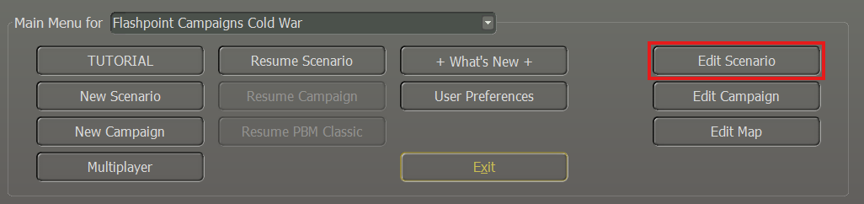The next popup window screen will show the Scenario Creation Checklist as shown below.

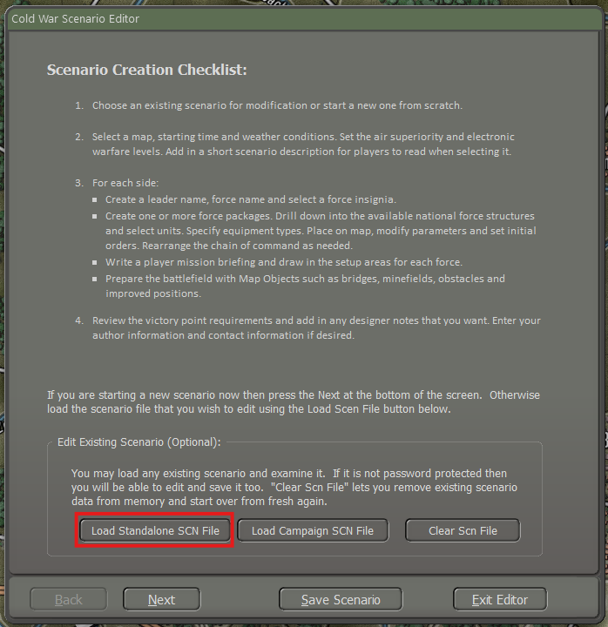

Select the “**Load Standalone SCN file**” button. To bring up the next popup window screen Module: Cold War: Southern Storm as shown below.

The core forces will be created in scenario 1 and then moved to each successful scenario. Additional core forces can be created in subsequent scenarios, and if a core force is not given a campaign scenario setup zone, then it will be removed from play.

Here we have selected the “**2nd Dragoons**” scenario as an example. Once highlighted, select the “**Proceed**” button.

Then select the “**Next**” button to load the scenario that you select in this case “**2nd Dragoons**”.

Now we need to select the” **Purpose of Scenario: First Scenario in** **Campaign**” button. Then select the “**Next**” button. The popup window we will need is the” Campaign Player1 Order of Battle”, in this case because we are doing a campaign with the US as the player. If it was a Warsaw Pact player, then we would have to show Player 2 Order of Battle instead.

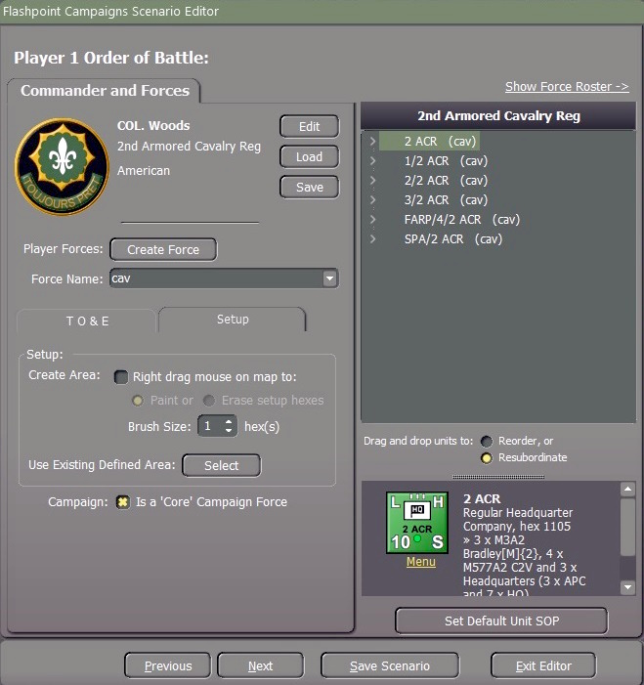

Forces can be marked as core from the “**Setup**” tab where there is a checkbox item for “**Is Core Campaign Force**”. If checked all units in that force (highlighted) or transferred into that force, will be designated as core units. Individual units cannot be set as core units. The unit must be highlighted to set as a core unit as shown in the example above. If you need to add another Unit to the Core Force, then you need to highlight each unit.

Make sure that when you do, you go to the Setup tab and select “**Is Core Campaign Force”** for each unit, for example, 1/2 ACR must be highlighted. Once you have finished selecting the Core Force for the Campaign select the “**Save Scenario**” button.

**NOTE**: core forces are tracked by force name so this cannot be changed later in the campaign. If a force starts as “2 ACR” as displayed in the example from above, then it must stay that way throughout the campaign.

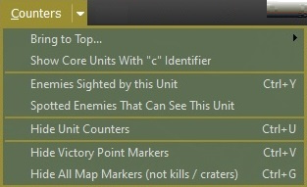

Unit counters can be displayed by selecting “**Show Core Units with “c”** **Identifier**” under the Counters Tab which when selected all core forces will be displayed with a lowercase “**c**” for “core” as needed so that the player can see which unit a core unit and which ones is not as shown below.

To create the next campaign scenario, start as you would any other new scenario, in this case, the scenario is titled “Dragoons” but when you get to the “Purpose of Scenario”, check the (**1**) “**Second or Subsequent in Campaign**” radio button as shown below.

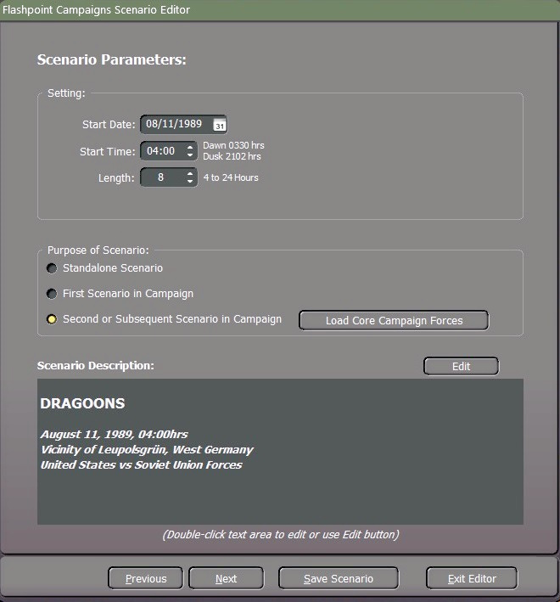

Then select (**2**) the “**Load Core Campaign Forces**” button. This will enable the Load Core Campaign Forces window popup which will list the various depot core forces available to you and let you select the core force from scenario one. As shown below.

As part of the scenario creation process, you will need to create new setup zones for the core forces and deploy them to the map. Do not change the core forces in any other way. Highlight the Core Force and then click on the “**Proceed**” button.

You can add additional friendly forces to the scenario, and these will be used but not rolled forward unless they are marked as “core”. You may also deselect core forces so that they will no longer be carried forward. Each time you save a campaign scenario it will create a new DPT file of the then core forces as “Core Forces from <scenario name>”.dpt. This becomes the depot file (and not the first one you created) that you should roll forward to the next scenario. *Yes, you do have to pay some attention to what you are doing, and if you start losing track of which depot file is which, your campaign will be mangled!*

1. In the Author Details area, you can enter your Name (real name and forum handle), Contact information (an email address if you want folks to contact you or leave it blank), Date Started (you should populate with the date you start working on the scenario), Last Revision (date auto populates with today’s date), Notes (Any info about the scenario or changes made in the revision).
2. The Scenario Validation area notes any issues in your scenario that must be resolved before your scenario is playable in the game. Click on the Update button any time you make changes to see what items are still needed to have a complete scenario.

When you have finished then select the “**Save Campaign**” button.

## Naming of the Campaign Scenario

When naming the Campaign scenario to reflect the country, for example for a US campaign, you would name it as "US1 - SN1" (SN = scenario) for the first scenario, and for the next scenario, you would label it as US1 – SN2 and so on.

# Campaign Editor

This section will guide you through the process of creating a campaign, with the final step covering how to edit an existing campaign.

## Create a Campaign

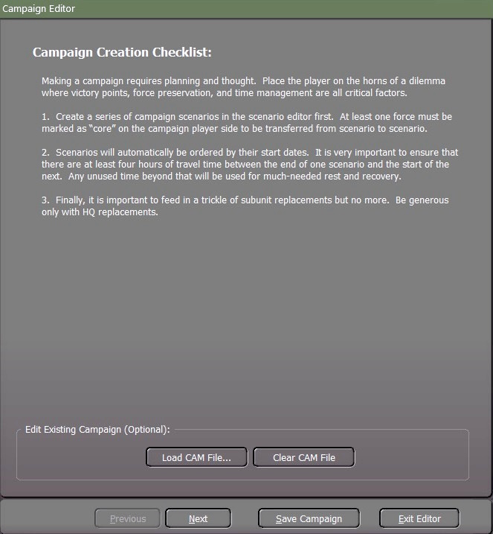

Because we’re going to put all the standalone scenarios into a campaign, we will have to select the “**Next**” button, which will take you to the Campaign Parameters window.

1. Provide a title for the campaign.
2. Choose the campaign player by selecting either player 1 or player 2. The campaign can only be experienced from one side. For this example, it will be Player 1.
3. In this section, you'll provide a campaign description that sets the tone and provides essential information for players engaging in the campaign.

Once you have finished the campaign parameters, select the “**Next**” button which will take you to the Campaign Scenarios selection window.

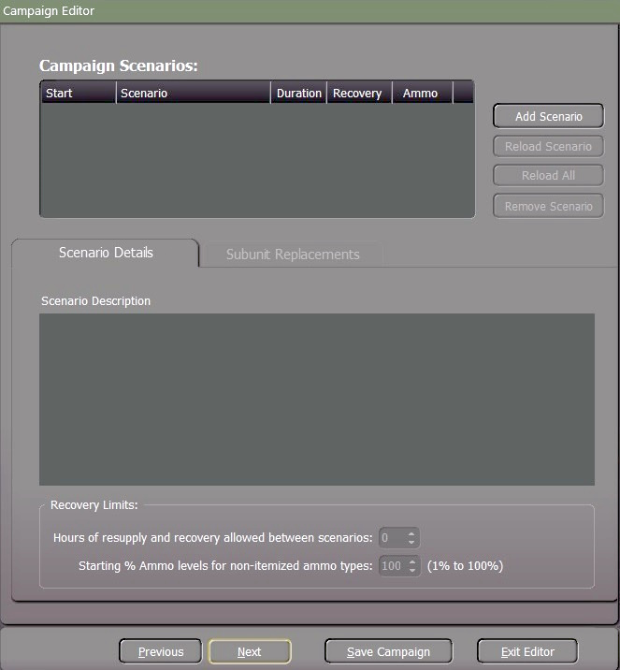

Now we’re going to select the standalone scenarios for the campaign. To do that we have to select the “**Add Scenario**” button and a “**Select and Load**” window will pop up. As shown below.

Here we will highlight and select the “**US1 – SN1 Fog of War**” scenario as the first scenario and then select “**Proceed**” which will return you to the Campaign Scenarios to load the next scenario until you have all the scenarios loaded.

**NOTE:** Scenarios will automatically be ordered by their start dates.

It is essential to ensure that there are at least four (4) hours of travel time between the end of one scenario and the start of the next.

The times between scenarios are critical to the core force recovery. Don’t make them too long or too short.

Any unused time beyond that will be used for much-needed rest and recovery.

Refer to **FM FCCW** **– 04/R1 Scenario Design Chapter 4.1.1 Setting, Creating a New Scenario** guideas your reference**.**

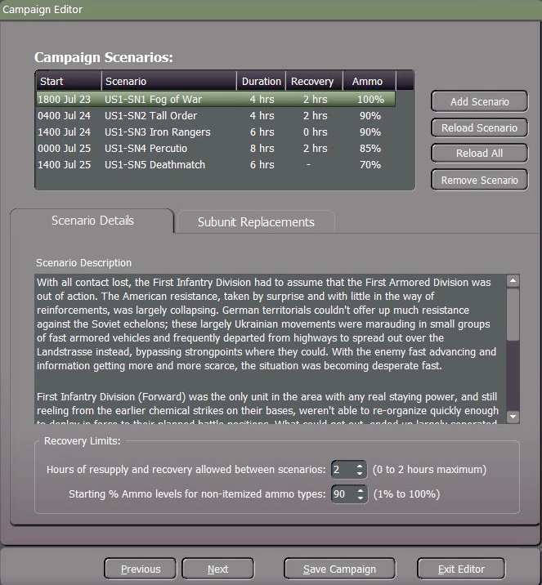

Recovery Limits,

1. Allowable duration for resupply and recovery between scenarios (ranging from 0 to a maximum of 2 hours).
2. Initial percentage levels of ammunition for non-itemized ammo types (ranging from 1% to 100%).

Once you have selected the hours of resupply and the ammo levels select the “**Subunit Replacements**” tab

The incorporation of “**Additions**” replacement equipment should be kept to a minimum. The availability of spare units in inventory during peacetime is limited, implying that the additions primarily involve equipment cannibalized from disbanded units elsewhere.

If the inclusion of replacements is necessary, it is advisable to prioritize Headquarters subunit replacements generously.

This ensures the flexibility to reconstitute various headquarters as required between scenarios.

## Edit a Campaign

To modify an existing campaign, click on the "**Load CAM File**" button.

Highlight the “Campaign Scenario” name for this example “Big Red One” and then select the “**Load**” button.

If you need to make a change or to update the Campaign Description select the “**Edit**” button. If you do not need to make any changes to the Campaign parameters or Campaign Description, then select the “**Next**” button.

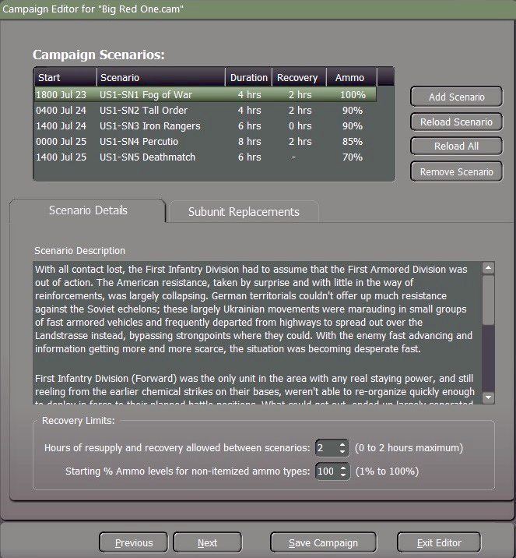

If you've created an additional scenario to add to this campaign, click the "**Add Scenario**" button.

In case you need to replace a scenario after making any adjustments, highlight the specific scenario and then choose the "**Reload Scenario**" button to reload only the selected scenario.

If you've made any adjustments to multiple scenarios and need to update them all at once, opt for the "**Reload All**" button, which will reload all scenarios simultaneously.

If you need to remove a scenario that you don’t want in the Campaign highlight it and then use the “**Remove Scenario**” button.

When you’re finished, then select the “**Save Campaign**” button which will cause the Save Flashpoint Campaign window to pop up.

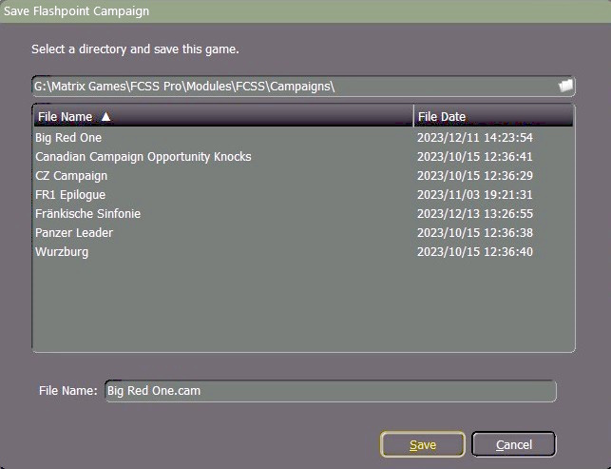

When you select the “**Save**” button the CAM file will be updated.

# Tips, Tricks, and Best Practices

Campaigns, whether in reality or the realm of PC games, inherently tell a story, with the core force serving as the primary narrative focus in FC. Craft a coherent path from the initial scenario to the last, avoiding repetitive engagements unless essential for the campaign's storytelling.

* “Begin with a comprehensive plan”. Develop a concise PowerPoint presentation detailing the major forces, scenario locations and times, and the overall intent for each phase.
* “Establish a detailed plan”, outlining the maps and forces involved. While attention tends to focus on the Core force, the strength of the AI side across all scenarios significantly influences the required strength of the Core force.
* “Maintain focus on a manageable scale”. Aim for 4-5 maps, as exceeding this threshold introduces overwhelming variables. This minimizes the risk of an unbalanced campaign that is challenging to adjust.
* “Prioritize testing”. Thoroughly test scenarios to address critical questions about reinforcements, timing between scenarios, AI force strength, Core force survivability, and adequacy of AI battleplans in accounting for human actions.
* “Consider the tempo”. Campaigns often work best with a crescendo in tempo, allowing players to acclimate to their forces before navigating through scenarios. This prevents the campaign from faltering in the initial stages due to insufficient force.
* “Craft subtle descriptions”. Without revealing too much, guide players on what to anticipate. Warnings about force preservation may hint at stronger opposition in later scenarios, while mentions of supply difficulties signal potential replacement challenges.
* “Provide support”. Once the Core force, AI forces, and scenarios are defined and tested, assess balance. If the Core force encounters challenges in specific scenarios, consider adding supporting forces. This approach offers more control over scenario-specific balance adjustments without disrupting the overall campaign dynamics.

# 

# Flashpoint Campaigns Credits

## On Target Simulations

* Lead Programmer and Head Honcho: **Robert "Ironman" Crandall**
* Data, Programming, Graphics, and Sound: **Jim "Cap’n Darwin” Snyder**
* Programming, Data, Models, and Research: **Jeff “Iron Mike” Sugden**
* Map Master, Programmer, AI, and Graphics: **William van der Sterren**
* Quality Czar and Testing Lead: **Charles “The Whip” Belva**
* Programming: **Kevin “SgtZDog” Zemon, Will Jackson, Alex Kriesel**
* Testing: **Tomasz Niedzinski**

## On Target Simulations Content Team

* Alexander “Stimpak” Schwarz, David “22sec” Whitt, Mike “MikeJ19” Johnstone, Joao Lima, Jurrie van der Zwaan, John “JohnO” Osborne, Jorgen “Jotte” Torgersson, Jo van der Pluym, Scott “WABAC” Gibbs and Steve “Mad Russian” Overton

## Cold War Beta Testers

* Names to be added before release

## Matrix Production Support

* **Erik Rutins, Maxim Klose-Ivanov**

# OTS on the Web

Matrix Games Forum: <https://www.matrixgames.com/forums/viewforum.php?f=10149>

Check Us Out on Discord: <https://discord.com/channels/911711314051739659/911711314257248331>

Check Us Out on Steam: *“Pending a page URL*”

**© 2025 On Target Simulations, LTD. All Rights Reserved. The images used and OTS Logo are property of On Target Simulations, LTD. All other logos and trademarks are the property of their respective owners.**